Learner Covlearn Account - How to Log in

- Details of your username and password will be given to you by your tutor.

- Click on Log in

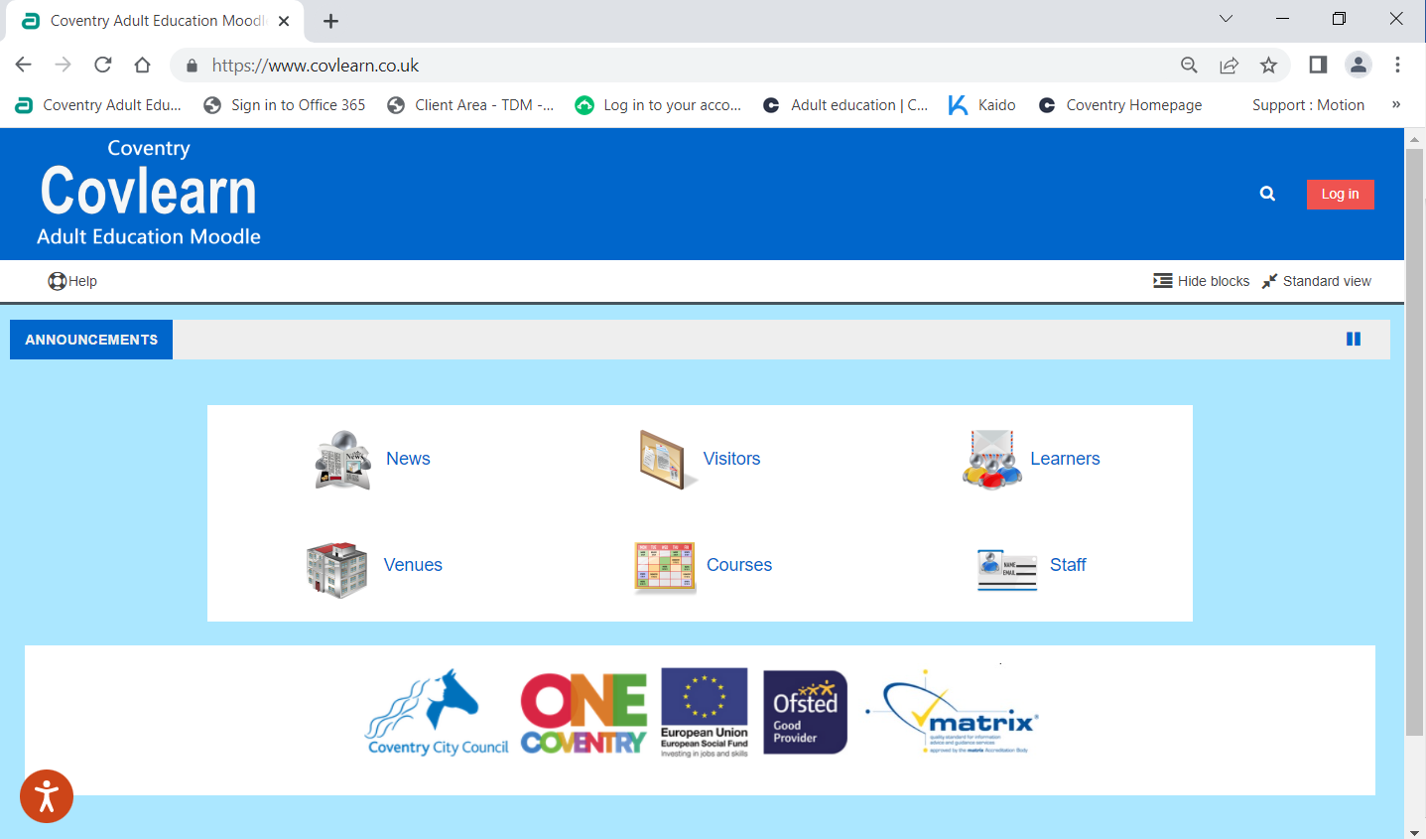

- Log in using username and password.

